https://www.perutravelexpertsb.com/tours/machu-picchu
MACHU PICCHU SIGNATURE EXPERIENCE
Discover Machu Picchu in One Unforgettable Day

MACHU PICCHU SIGNATURE DAY TOUR
Experience the wonder of Machu Picchu on a carefully planned full-day journey from Cusco, designed for travelers who want to make the most of their time in Peru without compromising comfort or quality.
Your adventure begins early in Cusco and takes you through the spectacular Sacred Valley to Ollantaytambo, where you will board the panoramic Vistadome Observatory train. As you travel alongside the Urubamba River, enjoy breathtaking views of the Andes, traditional villages, and lush mountain landscapes.
Upon arriving in Aguas Calientes, you will enjoy lunch at a local restaurant before continuing to the highlight of your journey: Machu Picchu, one of the New Seven Wonders of the World.
Accompanied by an expert guide, explore the most important temples, terraces, ceremonial areas, and viewpoints while discovering the fascinating history, engineering, and mysteries of the Inca civilization. With over 500 years of history, Machu Picchu remains one of the most extraordinary archaeological sites on Earth.
After your guided visit, return comfortably by train and private transportation to Cusco, arriving at your hotel the same evening.
This all-inclusive experience is perfect for travelers seeking a seamless, enriching, and unforgettable visit to Peru's most iconic destination.

- START OF THE TOUR. 8:00 am
We will pick you up from your hotel and head to the Ollantaytambo station. This part of the trip will take approximately 2 hours.
- DEPARTURE TIME OF THE TRAIN. 10:30 am
Your train will be the VISTADOME OBSERVATORY. The train ride will take approximately 1 hour and 45 minutes to reach the train station in the town of Aguas Calientes.
- ARRIVEL TIME TO AGUAS CALIENTES. 12:15 am
Once you arrive in the town of Aguas Calientes, your guide will take you to a restaurant for your lunch then your tour guide will lead you to the bus station, where you will have to wait on line to board the bus. The bus ride takes 25 minutes to reach the Inca citadel of Machu Pichu and then you will begin your tour of this enigmatic Inca city.
- START OF THE TOUR. 2:00 pm
Your tour begins at 2pm, here your guide will take you through the most important places of this beautiful Inca city visiting the most important temples and buildings, this tour will last approximately 2 hours and 30 minutes.

- END OF THE TOUR 4:30 pm
After your visit to Machu Picchu, you will take the bus back to the town of Aguas Calientes where you will have some free time to have dinner before taking the train EXPEDITION back to Ollantaytambo.
- DEPARTURE TIME OF THE TRAIN. 6:20 pm
Your trip from Aguas Calientes to Ollantaytambo will take 1 hour and 45 minutes. In Ollantaytambo a private car will be waiting for you and it will to take you back to Cusco City. This last ride will take almost 2 hours to get to Cusco and drop you off at your hotel.

Tour Highlights
✓ Visit one of the New Seven Wonders of the World
✓ Scenic Vistadome Observatory train journey through the Sacred Valley
✓ Expert guided tour of Machu Picchu
✓ Lunch at a local restaurant in Aguas Calientes
✓ Round-trip transportation from Cusco
✓ Return to your hotel in Cusco the same day
✓ Hassle-free logistics and personalized service
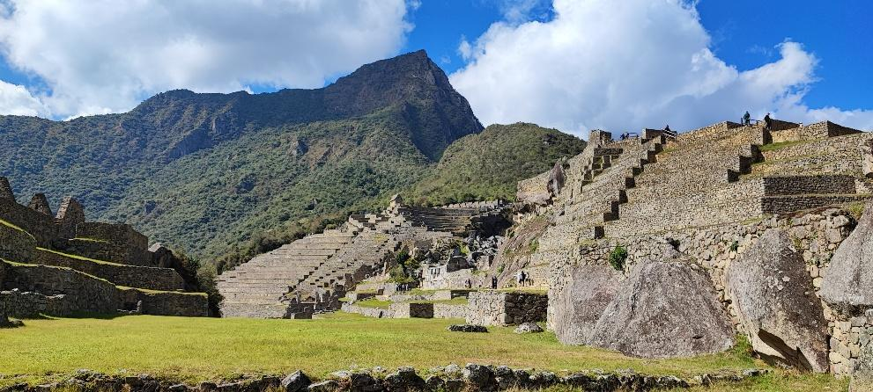
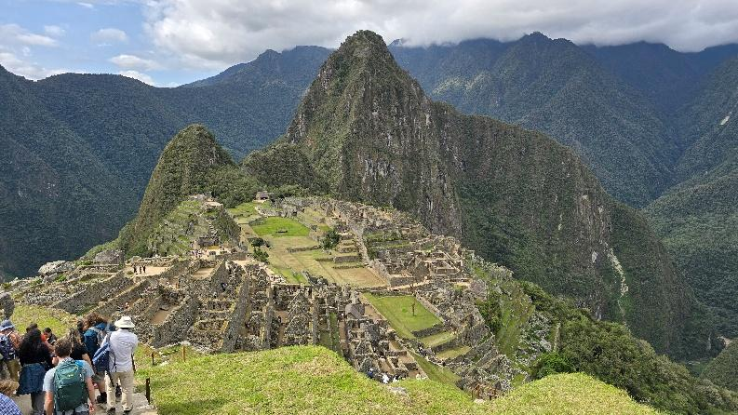

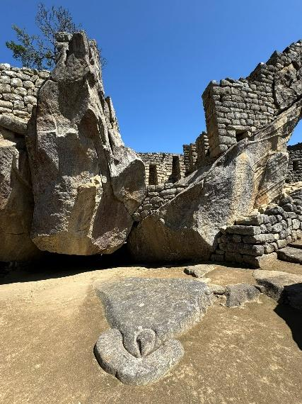
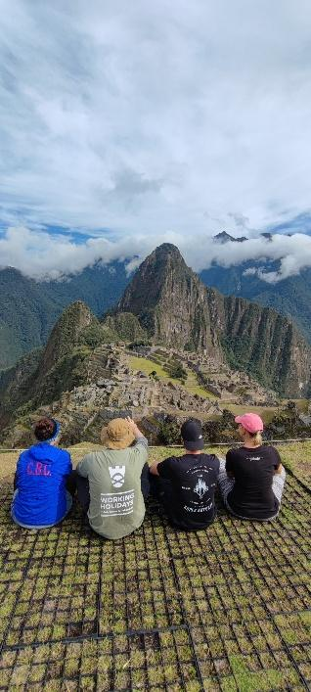
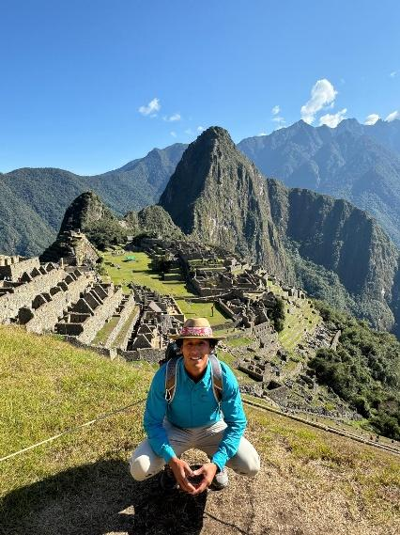
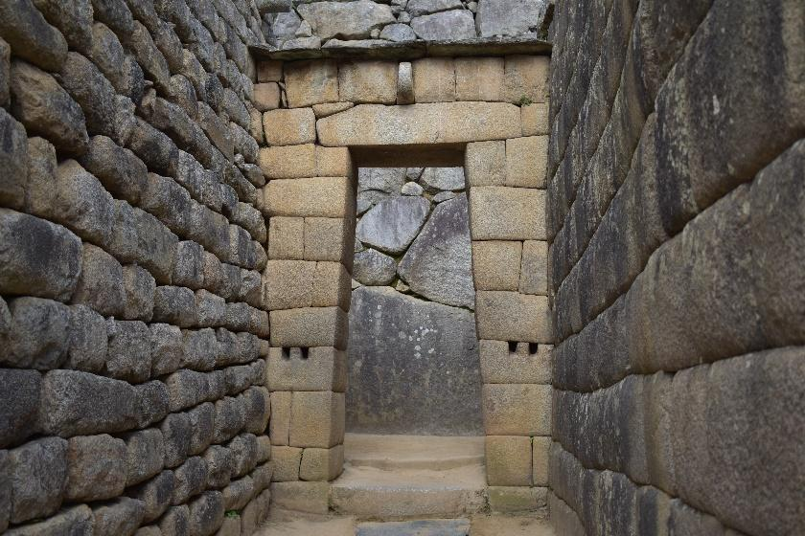

Details of the Day
Departure Place.
Hotel in Cusco.
End Location.
Your hotel in Cusco.
Departure Time of Machu Picchu tour.
Start at 8am.
What’s Included.
- Pick-up and drop off: at your hotel in Cusco.
- English speaking professional Tour Guide.
- Private Guiding Tour.
- Train Tickets from Ollantaytambo to Aguas Calientes Town. VISTADOME OBSERVATORY. 10:32 am
- Train Tickets from Aguas Calientes Town to Ollantaytambo. EXPEDITION. 18:20 pm
- Busses Tickets round trip from Aguas Calientes Town to Machu Picchu.
- Entrance fee to Machu Picchu.
- Meal: Lunch in Aguas Calientes Town.

What’s NOT Included.
- Hotel in Cusco City.
- Personal expenses and anything other than what are on the program.
- Meals: Breakfast and Dinner.
- Gratuities for Tour Guide and Driver.

Suggestions and Restrictions
Comfortable walking shoes, Sun Protection or rain ponchos, depending on the season, hat, Snacks, and a lot of curiosity.
A visit to Machu Picchu is more than a sightseeing tour—it is a journey into the heart of the Inca civilization and one of the most memorable travel experiences in the world. We take care of every detail so you can simply enjoy the adventure.

Tour Price.
Prices are per person and vary according to the number of travelers in the group.

1-2 PEOPLE | 3 PEOPLE | 4 PEOPLE | 5 PEOPLE | 6 PEOPLE | 7 PEOPLE | 8 PEOPLE
$ 629 | $569 | $559 | $539 | $519 | $509 | $499

